WEB UI Testing for Sauce Demo by Shreya Shrestha
I created automated tests for the Swag labs website (https://www.saucedemo.com/). I did some manual testing and created some test cases before automation testing. I used Selenium WebDriver with Python to check different parts of the website, like logging in, viewing products, and the checkout process. This helped me learn how to use Selenium to test websites and ensure they work correctly.

Sauce Demo is a practice website that looks like a real online store. You can look at products, add them to your shopping cart, and pretend to buy them. This project is about writing automated tests to check if the website is working properly, so users can have a good experience

Key skills developed
- Selenium WebDriver with Python
- UI testing principles
- Test case design and execution
- Test reporting and analysis

I prepared this documentation for my internship program. It covers the UI testing project I was assigned as a task from Mindriser Institute.

Manual Testing
Before automating the UI tests, I did so manual testing to gain some information and understanding about the project including its functionality and user interface. This includes various features as well as test scenarios, test cases and test documentation as well.

Test Cases
The following tables include the manual test cases I performed:
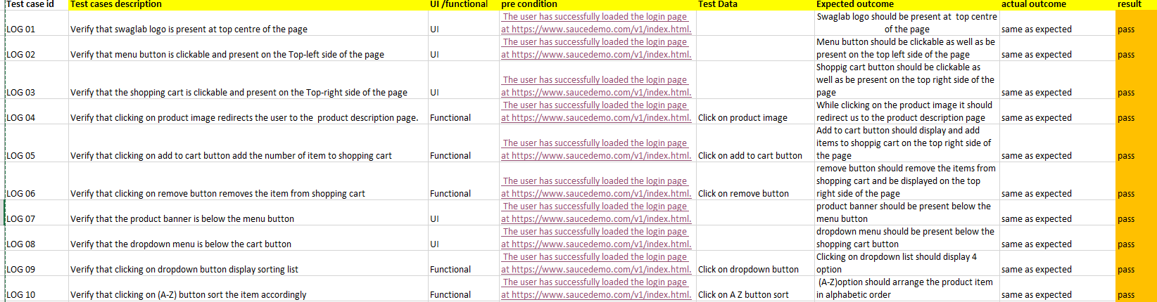
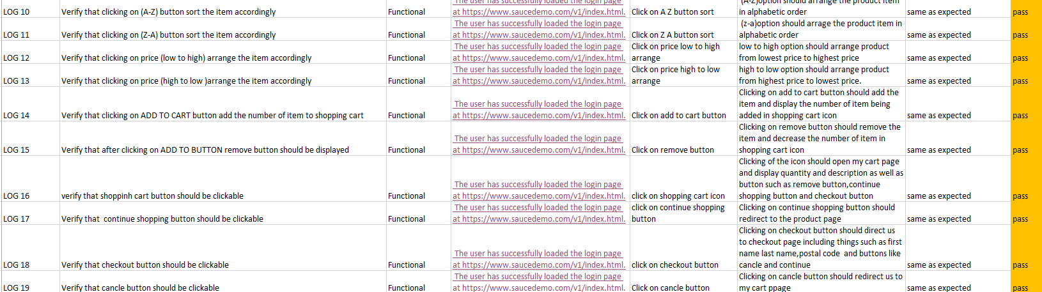
Figure 1 Test Cases for Swag labs

Findings
- Login page: To check if we can log in with the correct username and password. Also, check if it stops you from logging in with the wrong information.
- Products: To make sure the products are shown correctly on the website. To check if we can sort them (like from A to Z or by price)
- Shopping Cart: To check if you can add and remove things from your shopping cart.
- Checkout Process: To check if you can go through the entire checkout process, from entering your name and address to reviewing your order and getting a confirmation that your purchase went through.

Swag labs Automation Script

Setup
Here are some things before I started the automation:
- Python: Firstly, I installed python through the use of internet
- Selenium: Then I installed selenium using command (pip install selenium)

Script File:
- Swaglab.py

Script Functionality
Initialization:
I imported necessary Selenium modules such as webdriver, By, Select, and then assigning edge as my webdriver as well as defining the url, password and username.
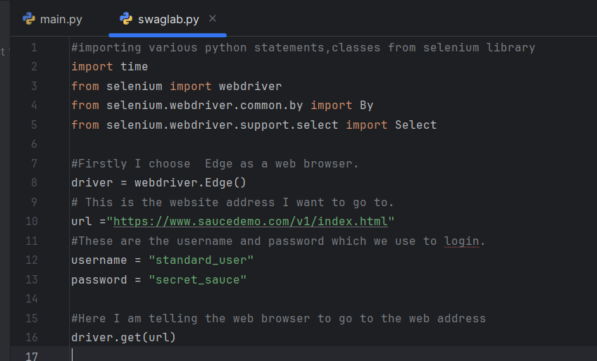
Login: After initialization I located the username and password input fields and clicked on login button and then It opens the product page.
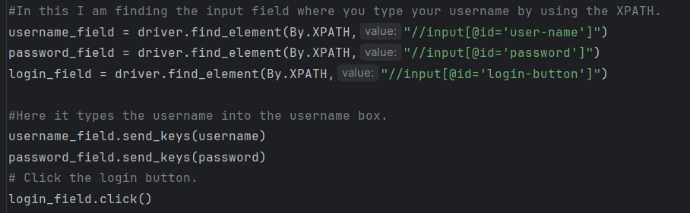
Product Sorting:
After logging in into to product page I located the dropdown button and checked if we can sort them (l from A to Z or by price).
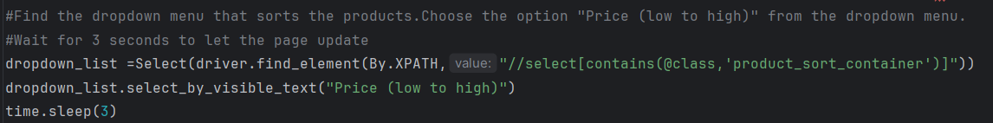
I used select_by_visible_text() method of the Select object to choose an option from the dropdown menu.
Adding Products to Cart:
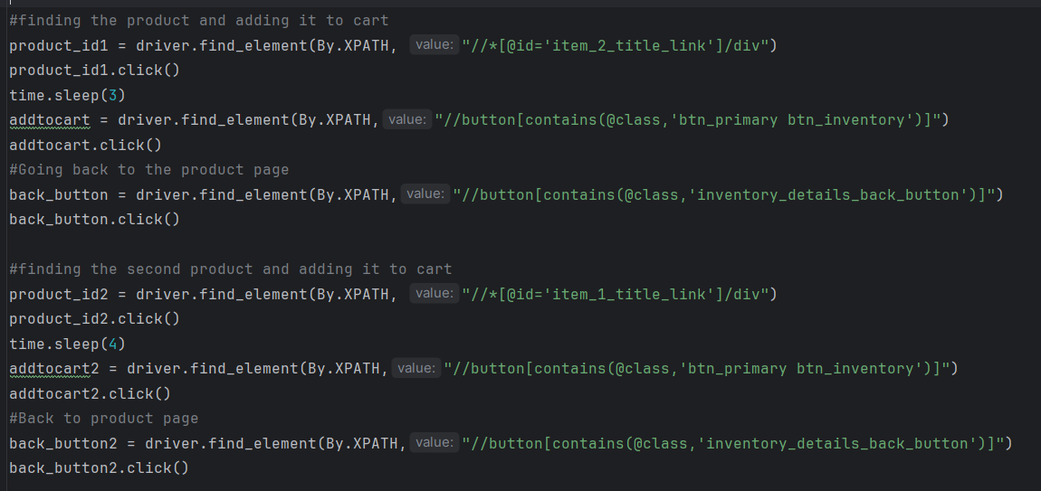I Located and clicked on the "Sauce Labs Onesie" product link. Now I clicked the "Add to Cart" button and clicked the "Back to products" button which send me back to product page after that I added another product to my shopping cart and went back to the home page.

Shopping Cart and Removal:
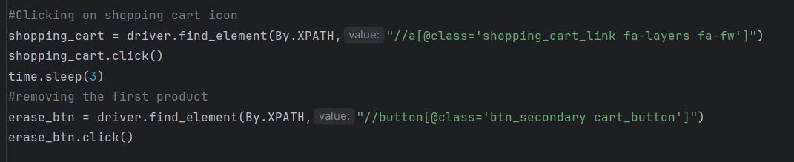
I clicked on shopping cart item and saw the list of product I added to my cart and removed first product from my shopping cart and clicked on continue button which led me to checkout page. I mostly have been using xpath for all of these.
Checkout
In checkout page there where three input fields such as first name,last name and postal code I filled those up and clicked on finish button which directed me to finish page.
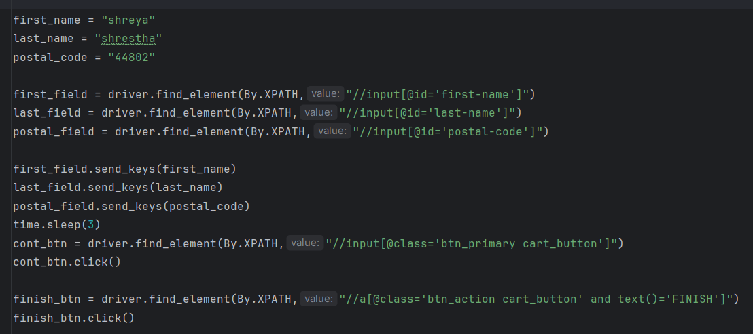
Navigation and Logout:
I clicked on the menu button which showd me various option but I choose to click on about page and use function such as driver.back to come back to previous page and the clicked to logout button which logged me out of swaglabs page.
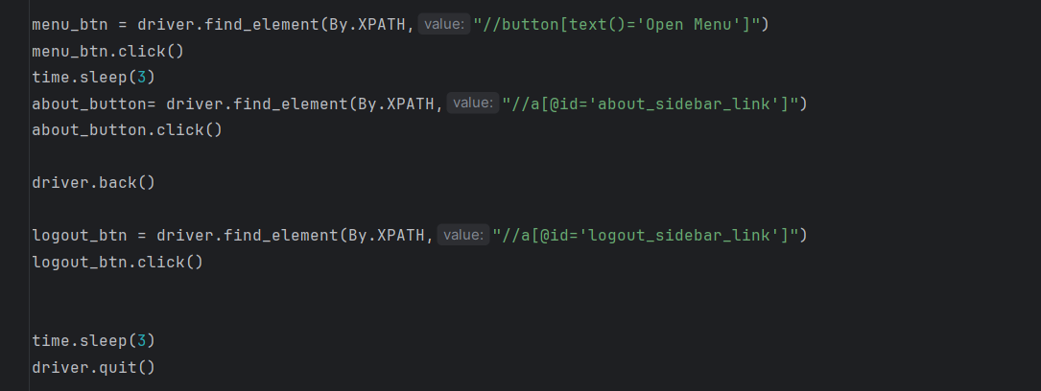
XPaths Used:
- //input[@id='user-name'] (Username field)
- //input[@id='password'] (Password field)
- //input[@id='login-button'] (Login button)
- //select[contains(@class,'product_sort_container')] (Product sort dropdown)
- //*[@id='item_2_title_link']/div (Sauce Labs Onesie link)
- //button[contains(@class,'btn_primary btn_inventory')] (Add to cart button)
- //button[contains(@class,'inventory_details_back_button')] (Back button)
- //*[@id='item_1_title_link']/div (Sauce Labs Bolt T-Shirt link)
- //a[@class='shopping_cart_link fa-layers fa-fw'] (Shopping cart icon)
- //button[@class='btn_secondary cart_button'] (Remove button)
- //a[@class='checkout_button'] (Checkout button)
- //input[@id='first-name'] (First name field)
- //input[@id='last-name'] (Last name field)
- //input[@id='postal-code'] (Postal code field)
- //input[@class='btn_primary cart_button'] (Continue button)
- //a[@class='btn_action cart_button' and text()='FINISH'] (Finish button)
- //button[text()='Open Menu'] (Open menu button)
- //a[@id='about_sidebar_link'] (About link)
- //a[@id='logout_sidebar_link'] (Logout link)

